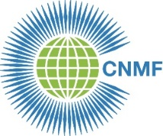
CNMF 22nd Biennial Meeting 2016

Royal College of Nursing 20 Cavendish Square London W1G 0RN
Friday 11 March 2016
hosted by the CNMF and the Royal College of Nursing

Toward 2020: celebrating nursing and midwifery leadership

DRAFT MINUTES

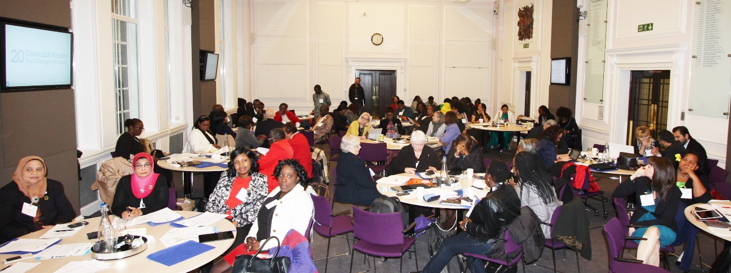

1. | Opening and welcome  Ms Ramziah Binti Ahmad, President, Commonwealth Nurses and Midwives Federation (CNMF) welcomed participants to the meeting. Ms Ahmad officially opened the 22nd CNMF Biennial Meeting.  On behalf of the Royal College of Nursing UK (RCN), Ms Cecelia Anim, RCN President, welcomed participants to the RCN and said how pleased the RCN was to be able to host the 22nd CNMF Biennial Meeting. Ms Anim said that the CNMF Biennial Meeting was an opportunity to share experiences, reflect on how to improve nursing and midwifery care, and help shape the future.
2. | Introduction of CNMF Board  The CNMF President introduced Professor Kathleen McCourt from the United Kingdom who is the CNMF Vice President and other members of the CNMF Board. Ms Ahmad advised that two Board members would be retiring at this Biennial Meeting: Ms Lee Thomas from Australia who has been CNMF Board member for the Pacific Region (represented by Ms Julianne Bryce); and Mrs Paul Hancock from the United Kingdom, who has been CNMF Board member for the Europe Region. Ms Annie Butler from Australia has been elected as Board member for the Pacific Region and Mr George Saliba from Malta has been elected as Board member for the Europe Region. Other Board members in attendance were Ms Hossinatu Mary Kanu from Sierra Leone, Board member for the West Africa Region; Mr Paul Magesa Mashauri from Tanzania, Board member for the East, Central and Southern Africa Region; and Mrs Rosemarie Josey from the Bahamas, Board member for the Atlantic Region. Ms Ahmad advised that Mr Keerthi Wanasekara from Sri Lanka was refused a visa to the United Kingdom so was unable to be present.  Introduction of Delegates  Delegations from the following countries introduced themselves to the meeting: Australia, Bahamas, Botswana, Cook Island, Cyprus, Ghana, India, Jamaica, Malaysia, Malta, Rwanda, Sierra Leone, South Africa, Tanzania, Trinidad and Tobago, and the United Kingdom. Apologies were received from Zimbabwe, Uganda, Cameroon, Sri Lanka, Barbados, and Canada.  Welcome to new members  Ms Ahmad welcomed new members to the CNMF: The Rwanda Nurses and Midwives Union and the Brunei Darussalam Nurses Association were admitted as full members. Ms Ahmad also welcomed Affiliate and Associate Membership respectively the Nurses for Nurses Network Australia and CGFNS International.
3. | President’s Report  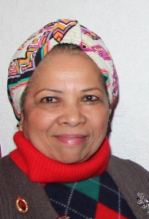  Ms Ahmad told delegates she was delighted to welcome them to the 22nd CNMF Biennial Meeting and said she hoped all delegates would also be attending the 3rd Commonwealth Nurses and Midwives Conference to be held at the Royal College of Physicians Regent’s Park over the weekend. She said she as looking forward to receiving the Executive Secretary, Treasurer and Board members reports and was confident CNMF members would be pleased with the activities of the CNMF over the past two years. Ms Ahmad thanked CNMF Board members for their input into the CNMF and the commitment of their time and energy.  Ms Ahmad paid tribute to the CNMF Executive Secretary and Treasurer for their hard work in raising the profile of the CNMF, obtaining ongoing funding to continue CNMF activities; and making the CNMF a viable and effective organisation. Finally, Ms Ahmad thanked the Royal College of Nursing, the CEO, the President and the Council for the wonderful support they provided to the CNMF.
4. | Executive Secretary’s Report  The Executive Secretary’s power point presentation is attached as a separate PDF file to the draft minutes.
5. | Treasurer’s Report  The Treasurer’s report is attached as a separate PDF file to the draft minutes. Ms Angela Neuhaus who has been CNMF Honorary Treasurer since 2008 announced her retirement from that position as soon as a suitable candidate could be appointed.
6. | Board Member’s Report  Board members from the CNMF Pacific; Atlantic; West Africa; Europe; and East, Central and Southern Africa Regions addressed the delegates and outlined CNMF activities in their regions over the past two years, their achievements, and the challenges they faced.  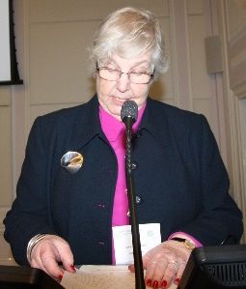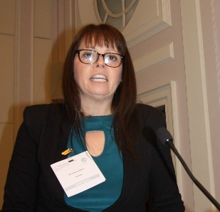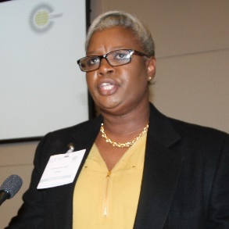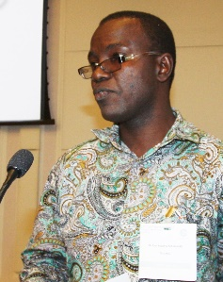  Mrs Paul Hancock Ms Julianne Bryce Ms Hossinatu Mary Kanu Mrs Rosemarie Josey Mr Paul Magesa Mashauri  Europe Pacific West Africa Atlantic East, Central and Southern Africa  It was moved that the reports were received. Moved: Malaysia, Seconded: Botswana.
7. | Biennial Address: Dr Linda Lewis, Chief Executive Officer, American Nurse Credentialing Centre  Dr Lewis shared with participants the importance of transformational leadership which she defined as: Leaders who stimulate and inspire followers to achieve extraordinary outcomes and, in the process, develop their own leadership capacity. She said the qualities of a transformational leader were that they seek out experiences to transform themselves; articulate the future and bridge it to the present; challenge the status quo; know what not to change; take on obstacles; build capacity to embrace chaos; and know how to run the marathon and go the distance.  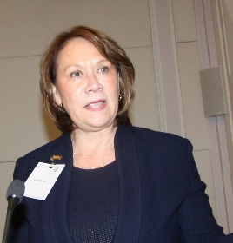  As nurse leaders, Dr Lewis said, the challenges we face are enormous heading forward: an ageing population; the economy; chronic disease; access to care; communicable disease; public health infrastructure; scope of practice; shortage and maldistribution of health care professionals; proliferation of new health care roles; health information technology; rising health care costs; and nursing work environments. Although there are many challenges in health care now, there are also many opportunities for nursing. Dr Lewis said a transformational leader is one who identifies and communicates a clear vision and values. Health care today is experiencing fast, intense change. Leaders must help people meet the demands of the future. They must show their organizations why change is necessary and share how each individual and area of work is a part of achieving change. As the organization moves into the future, leaders should listen to, influence, and challenge others. Leaders partner with staff to create new solutions to challenges.
8. | Welcome remarks: Ms Peggy Vidot, Permanent Secretary, Ministry of Health Seychelles  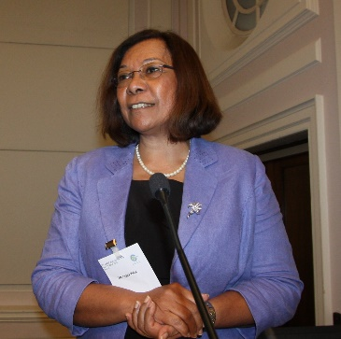  Ms Peggy Vidot shared with delegates her leadership journey including her time as Chief Nursing Officer of the Seychelles, as former President of the then Commonwealth Nurses Federation, and as Health Advisor for the Commonwealth Secretariat. Ms Vidot said that having a vision, pursuing education, being committed, working hard, and not giving up, were the key characteristics of her career. Ms Vidot said she felt extremely privileged to have had such an interesting and rewarding career and said that when she commenced her nursing education she had no idea of the journey ahead of her. While some of the journey had been challenging and difficult, it was far outweighed by the personal and professional achievements and satisfaction.
9. | Policy discussion 1: Are there advantages for a professional association in registering as a trade union and if so, what are they?  The policy discussion was led by Barbados, Trinidad and Tobago, and Jamaica who shared their experiences in transforming their professional associations so they also had trade union responsibilities and could represent nurses and midwives industrially and act as bargaining agents for salaries and conditions in the workplace.  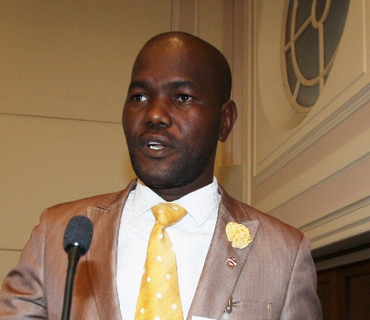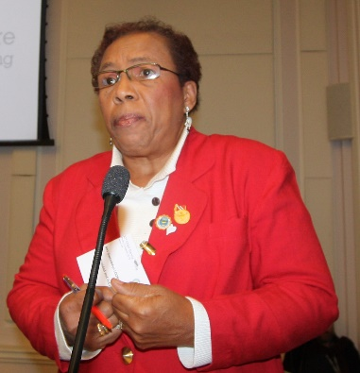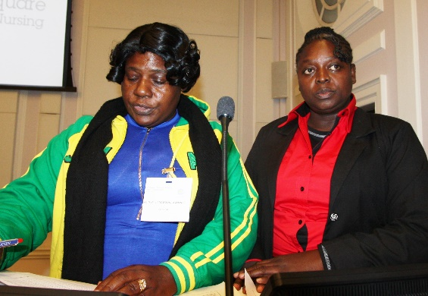
10. | Presentation: Ms Fleur Anderson, Water Aid and the WASH initiative  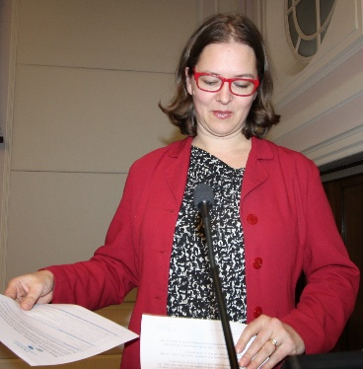  Ms Anderson thanked the CNMF for the opportunity to discuss Water Aid and the water, sanitation and hygiene (WASH) initiative. Ms Anderson said the WHO has estimated that 38% of health care facilities in low and middle income countries lack access to water; 19% do not have adequate sanitation; and 35% do not have soap for handwashing. In sub-Saharan Africa, 42% of health care facilities do not have access to water. It is estimated that one in five babies who die in their first month in the developing world could have survived if they had been washed in clean water and cared for in a clean environment by people who washed their hands.  Ms Anderson invited participants to become WASH champions in their own countries. She said that nursing and midwifery leaders could be a huge influence in improving water, sanitation and hygiene, not only for patients but for themselves also as health workers. She foreshadowed the development of a campaign in which participants could be involved asking governments to commit, by 2030, that every health care facility will have a reliable and sufficient supply of clean running water, safe toilets for patients and staff (with locks, lights, child and disability friendly), functional sinks and soap for health workers and patients, and sufficient supplies of cleaning materials to maintain a hygienic and safe environment.
11. | Policy discussion 2: Lower level cadres doing nursing work (nursing assistants, health care assistants etc) - Are they nurses? Should they be regulated by the nurse regulatory authority? Should there be nursing input into standards, education, and scopes of practice?  The policy discussion was led by Ghana, the Bahamas, and South Africa. These countries considered that any health worker who was doing nursing work should be part of the nursing family. They should be well educated so they could provide safe practice; registered nurses should have input into their education and scope of practice as they would be working with them and delegating care to them; and that any health worker providing care to patients or clients should be licensed and regulated by a regulatory authority.  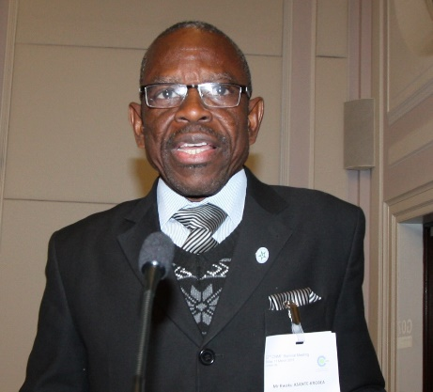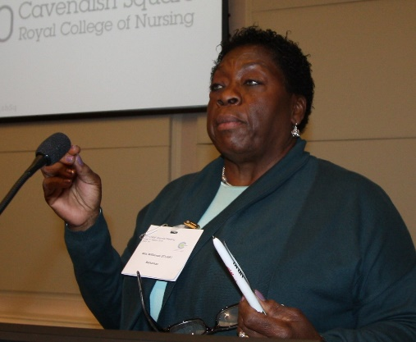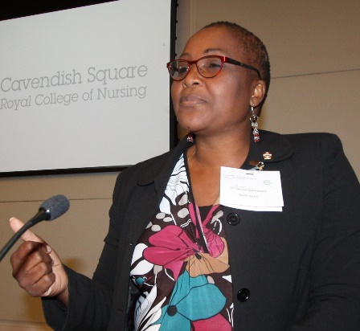
12. | Presentation: Dr Joanna Riha, Policy Director, UK All Parliamentary Group on Global Health  Dr Riha shared with participants, the UK All Party Parliamentary Group on Global Health review of nursing, with support from the Royal College of Nursing, to look at what needs to be done to strengthen the nursing work force globally in terms of education, recruitment, retention, role definition and regulation. The focus will be on what the UK can do to facilitate improvement in both capabilities and capacity. While the report can make recommendations only to the UK Parliament and Government it may be influential on other organisations. The opportunity provided by the CNMF Biennial Meeting and 3rd Commonwealth Nurses and Midwives Conference to talk with, listen to and gain input from nursing and midwifery leaders from other countries is very welcome.  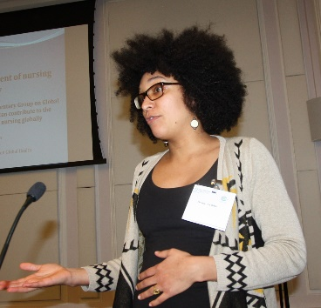
13. | Policy discussion 3: Clinical career structure development. What are some of the options for developing a career structure for nurses who want to remain or specialise as clinicians?  The policy discussion was led by Malaysia, the United Kingdom and Australia. Delegates considered that having a clinical career structure was extremely important however were undecided as to what was the most appropriate structure. Malaysia, the UK and Australia shared the clinical career structures from their own countries.  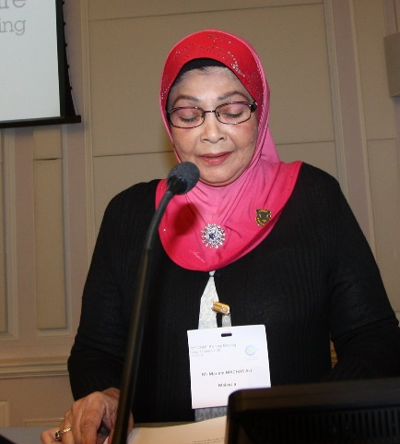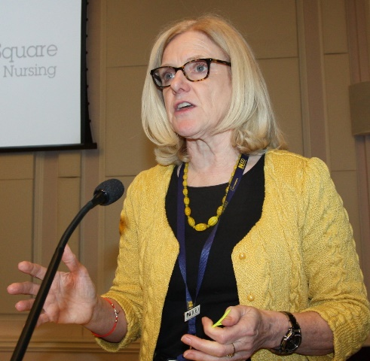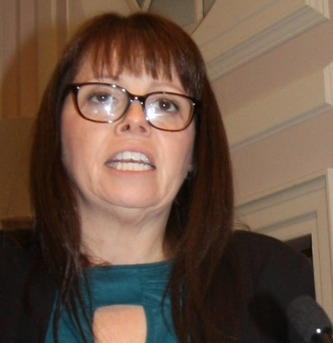  Following the policy discussions, CNMF members resolved to continue the discussions by email over the coming two years to share experiences, ideas and solutions.
14. | Closing comments from delegates and close of 22nd Biennial Meeting  Country delegations were invited to make closing comments. Ms Ahmad thanked participants for their input into the meeting and into the discussion. She thanked all the guest speakers and particularly the RCN for hosting the meeting and providing the venue and sustenance. In recognition of their service to the CNMF, Ms Ahmad gave a small gift to retiring Board members, Mrs Paula Hancock and Ms Lee Thomas. Ms Ahmad acknowledged and thanked Mrs Angela Neuhaus who was retiring as Honorary Treasurer for all her hard work and commitment to the CNMF since 2008. Ms Ahmad noted that all the CNMF work in Zimbabwe had been as a direct result of Mrs Neuhaus’ lobbying for funding. Ms Ahmad closed the meeting and invited participants to join the RCN Reception to celebrate their 100th Anniversary.  _________________

