**POLICY STATEMENT ON CAREER STRUCTURES FOR NURSES AND MIDWIVES**

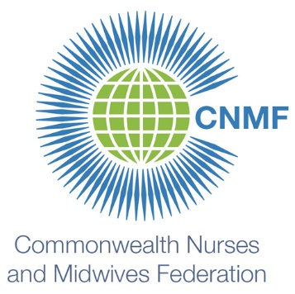

The Commonwealth Nurses and Midwives Federation supports career opportunities and career structures for nurses and midwives that allow their progression from beginner to expert in all areas of practice: as managers and administrators; as academics and researchers; as clinicians; as regulators; and as professional and industrial officers. Career progression from beginner to expert should be equivalent in status, title, and remuneration between areas of practice.

|  |  |  |  |  |  |  |  |  |  |  |  |  |
| --- | --- | --- | --- | --- | --- | --- | --- | --- | --- | --- | --- | --- |
| **EQUIVALENCE IN STATUS, TITLE AND REMUNERATION** |  | **MANAGER**  **ADMINISTRATOR** | **ACADEMIC**  **RESEARCHER** | | **CLINICIAN** | | **REGULATOR** | | **PROFESSIONAL**  **INDUSTRIAL** | |  | **EQUIVALENCE IN STATUS, TITLE AND REMUNERATION** |
|  | **EXPERT** | | **EXPERT** | | **EXPERT** | | **EXPERT** | | **EXPERT** |  |
|  | **PROFICIENT** | | **PROFICIENT** | | **PROFICIENT** | | **PROFICIENT** | | **PROFICIENT** |  |
|  | **BEGINNER** | | **BEGINNER** | | **BEGINNER** | | **BEGINNER** | | **BEGINNER** |  |
|  | **NOVICE** | | **NOVICE** | | **NOVICE** | | **NOVICE** | | **NOVICE** |  |