POLICY STATEMENT ON NURSING AND MIDWIFERY WORK

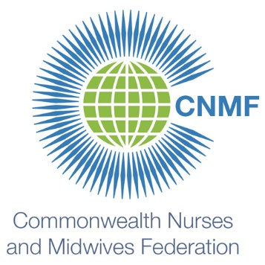

The Commonwealth Nurses and Midwives Federation supports the position that all workers providing nursing and midwifery care are part of the nursing and midwifery family: from novice to expert, from lower level cadre to higher level cadre. Position titles should include the words: nurse or nursing; midwife or midwifery so that the worker is clearly identified as being a part of the nursing and midwifery profession (for example registered nurse; enrolled nurse; nurse or nursing assistant; registered midwife; enrolled midwife; midwife or midwifery assistant). As all nurses and midwives work together as a team, delegating care to or between each other, in order to protect worker and client, all workers providing nursing and midwifery care should be educated within a nursing or midwifery faculty, and be regulated by a nursing and midwifery regulatory body.

