POLICY STATEMENT ON PROFESSIONAL AND INDUSTRIAL REPRESENTATION FOR NURSES AND MIDWIVES

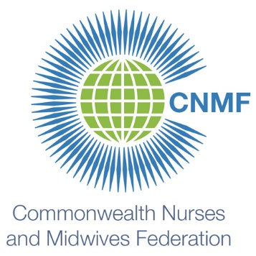

The Commonwealth Nurses and Midwives Federation endorses the position that all workers who are part of the nursing and midwifery family (however titled), and who provide nursing and midwifery care, should be eligible to be a part of, and be represented professionally and industrially by, an organisation that is led or governed by nurses and midwives who can provide input into and influence decisions made on their behalf.

Professional and industrial issues for nurses and midwives are interlinked: industrial issues frequently have professional implications in the same way that professional issues frequently have industrial implications. Nursing and midwifery professional bodies may have an industrial mandate and nursing and midwifery industrial bodies may also have a professional mandate. Professional and industrial representation for nurses and midwives may be conducted by the same organisation however if these bodies are separate organisations, they should work constructively together in the best interests of nurses and midwives.

Professional and industrial issues may include: legislation and regulation, initial and continuing education, standards, competencies, career structure, scopes of practice, position descriptions, remuneration, and occupational health and safety.

