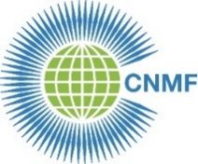
CNMF 26th Biennial Meeting of Members 2024
26 September 2024

REGISTRATION FORM

PLEASE NOTE
Full Members are those individuals belonging to a national nursing or midwifery association member of CNMF. Each Full Member association is entitled to two official delegates who will carry the vote. To vote, the Full Member association must have paid all membership fees owing. Other attendees from a Full Member association may seek attendance as Observers.
Each individual attending must complete a registration form.

Country:

Type of member (Full, Associate, Affiliate, Individual, Observer):

Title (Miss; Ms; Mr; Dr: Professor):

Last (family) name:

First name:

Email address:

Repeat email address:

Return to: cnf@commonwealthnurses.org BY Friday 6 September 2024

Registration will be acknowledged.

